1

**CST 239: Activity 1**

Michael Melichar

CST 239: Programming in Java II

David Couch

July 10, 2022

**Part I: Hello World Deliverables**

*Screenshot of the Eclipse “About” Box*

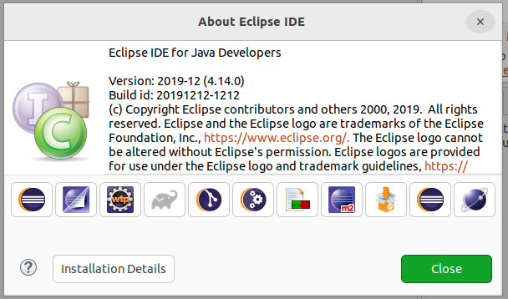

*Screenshot of console output for Hello World class*

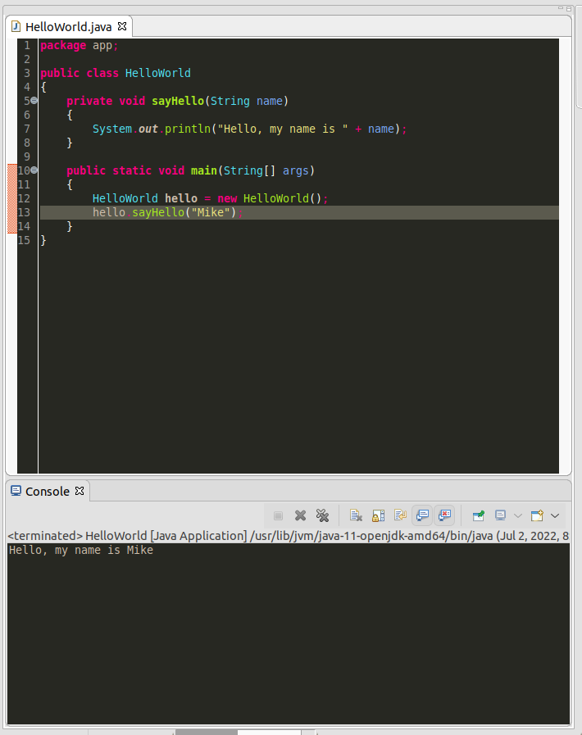

**Part II: Person class Deliverables**

*Theory of Operation Write-up*

The way the Person class should operate is that a person can be instantiated with a method call to the constructor Person that has no default constructor. They must provide, in this order, an int age, String firstName, String lastName, double weight, and double height. There are getter and setter methods for all of these parameters that allow for reading and modification of each parameter as needed. The three methods of Person are walk, run, and sleep. Walk and run simply print a message to the console, where sleep requires a parameter for duration of sleep, printing a message using the sleep duration parameter passed into the method.

*UML Class Diagram*

***TBD on my windows machine and pasted here: if you receive this as a submission please ask me for the correct submission***

*Screenshot of console output of the Person Class*

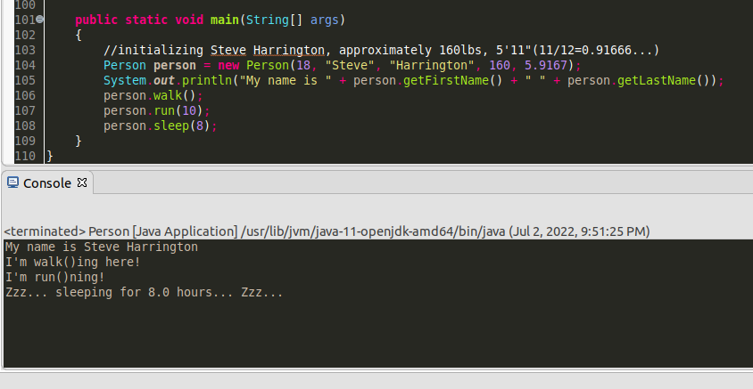

**Part III: Race Car Class Deliverables**

*UML Class Diagram*

***TBD on my windows machine and pasted here: if you receive this as a submission please ask me for the correct submission***

*Screenshot of Starting, Driving, and Stopping the Car Class*

